The German States
1800 - 1850

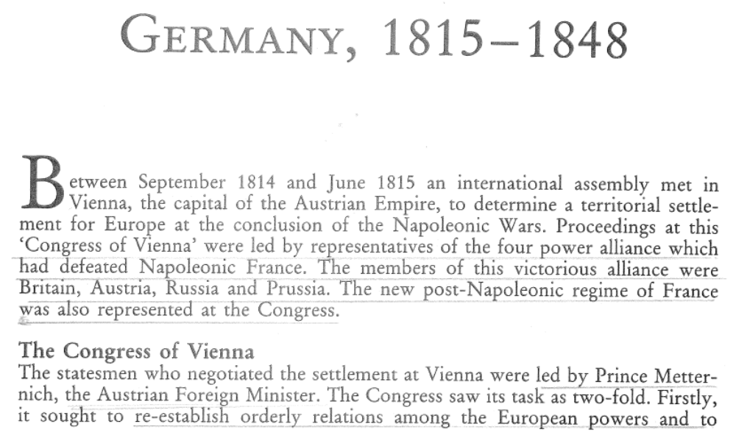

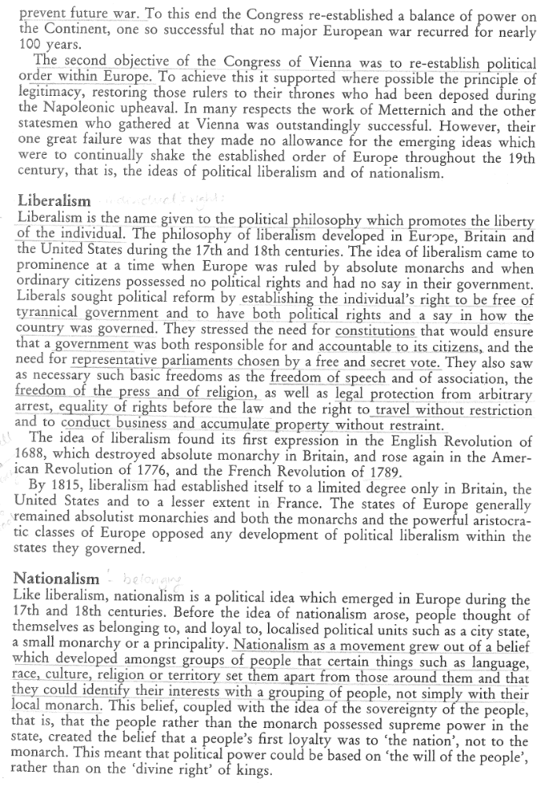
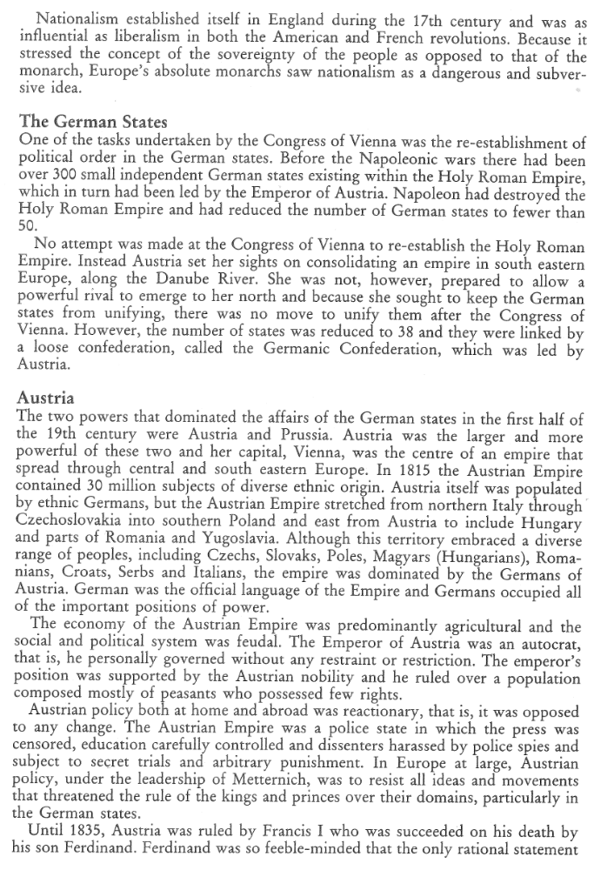

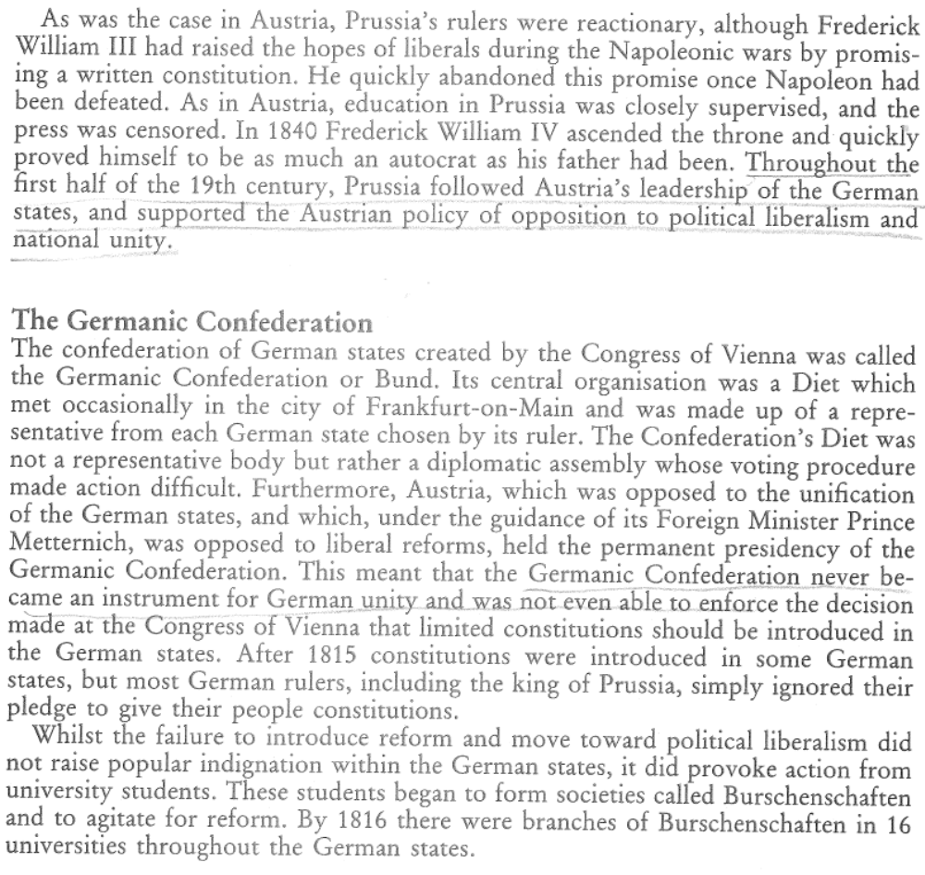
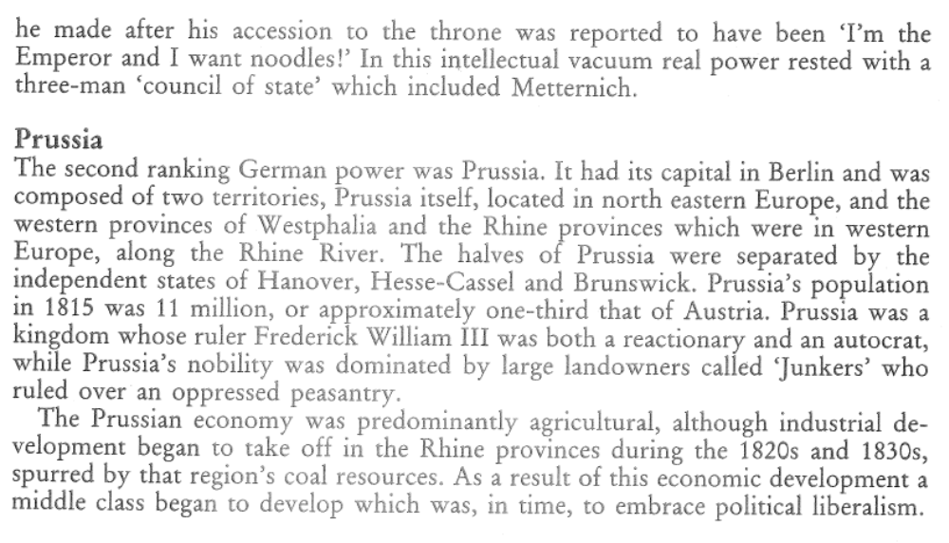
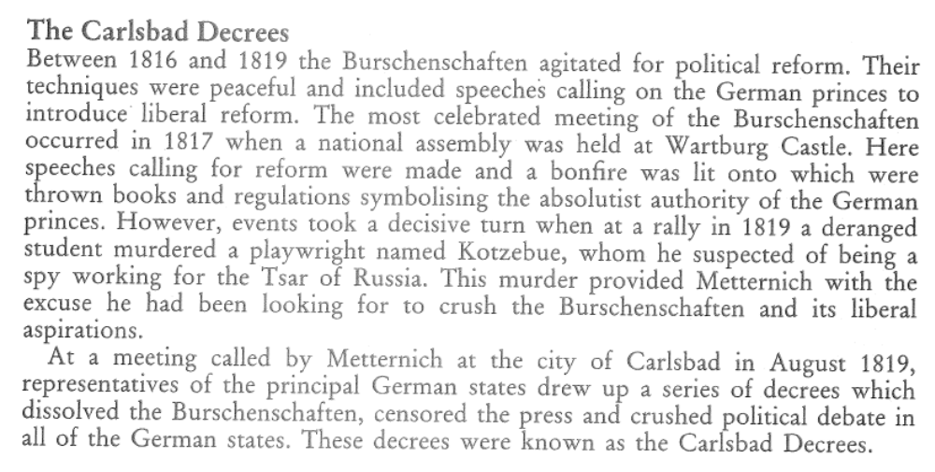

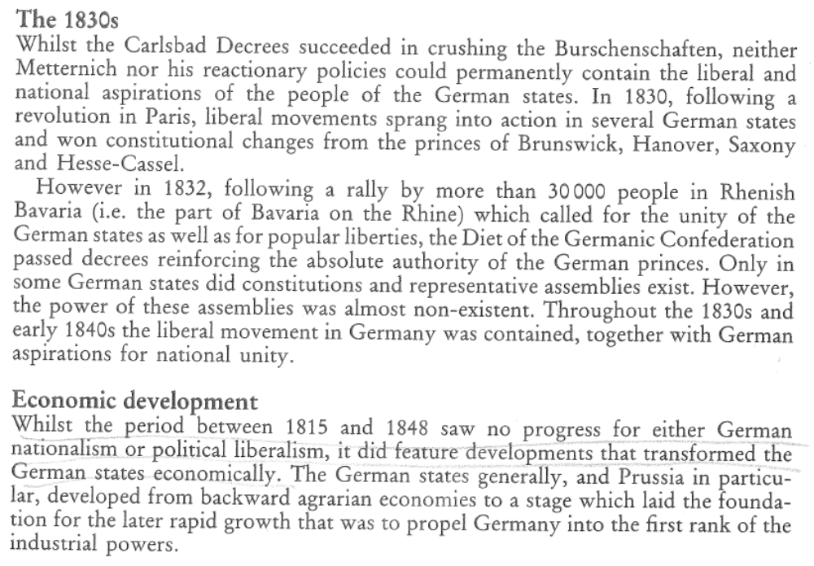
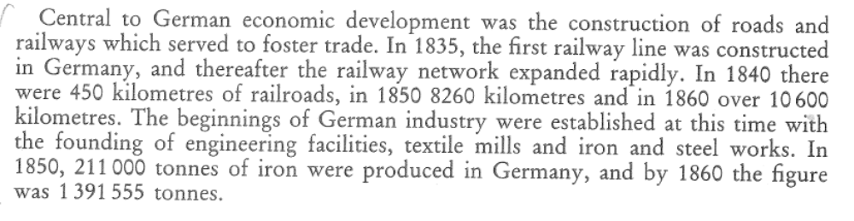
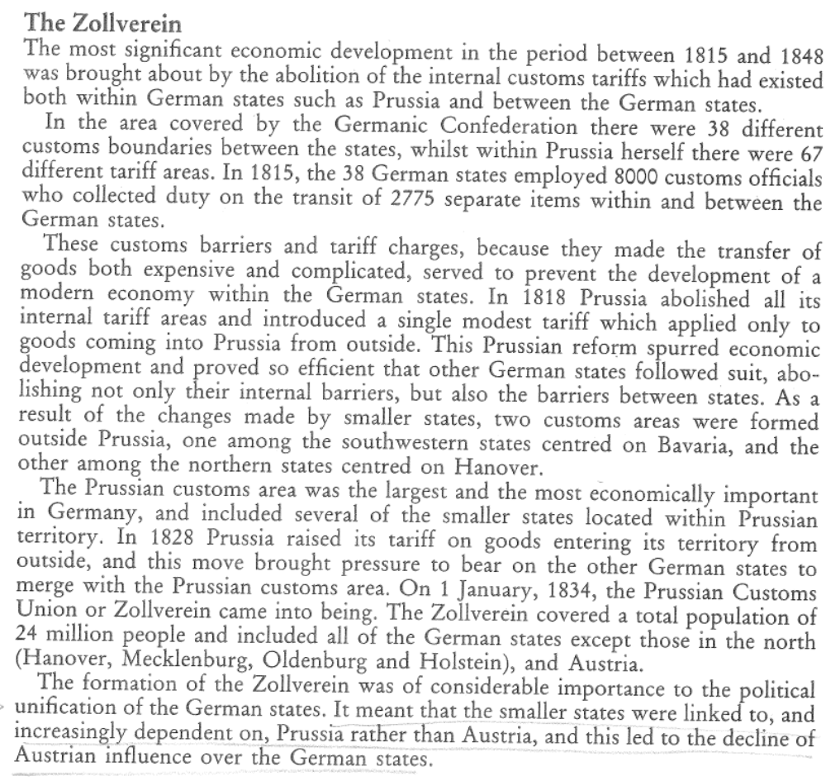
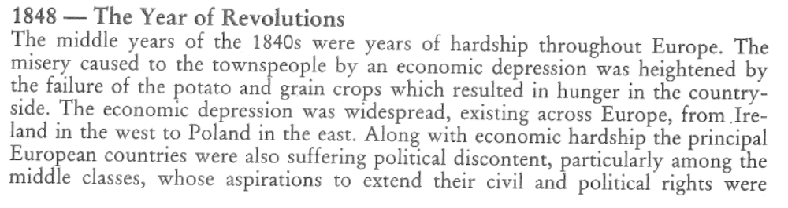
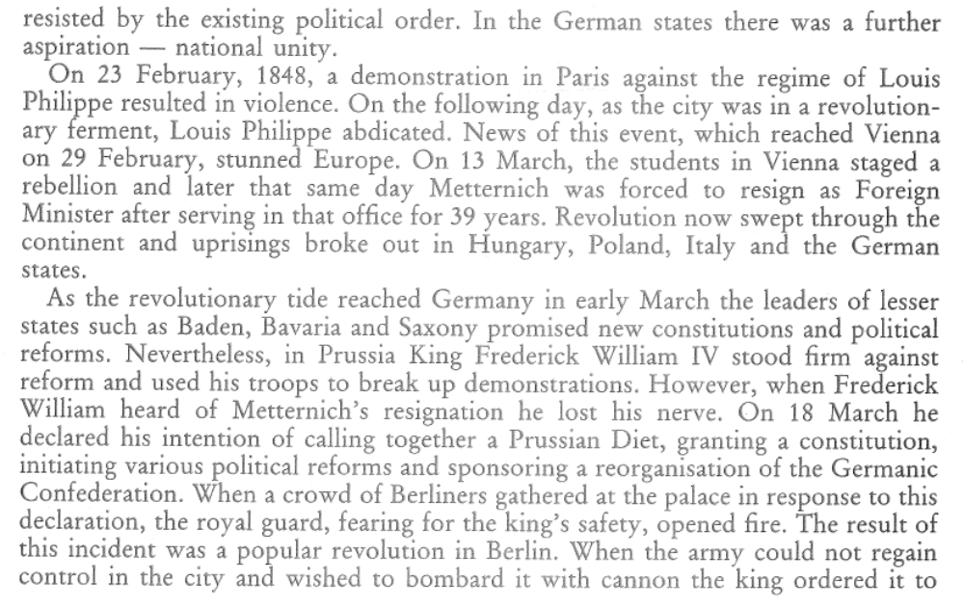
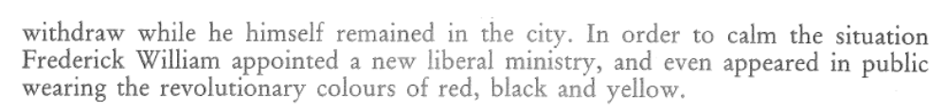
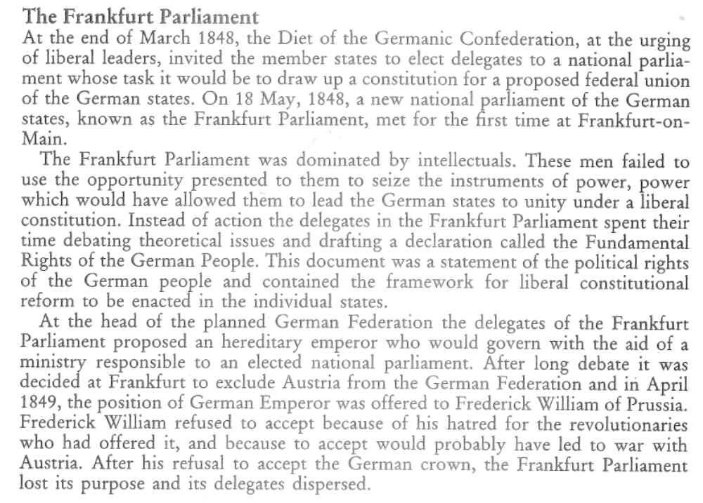
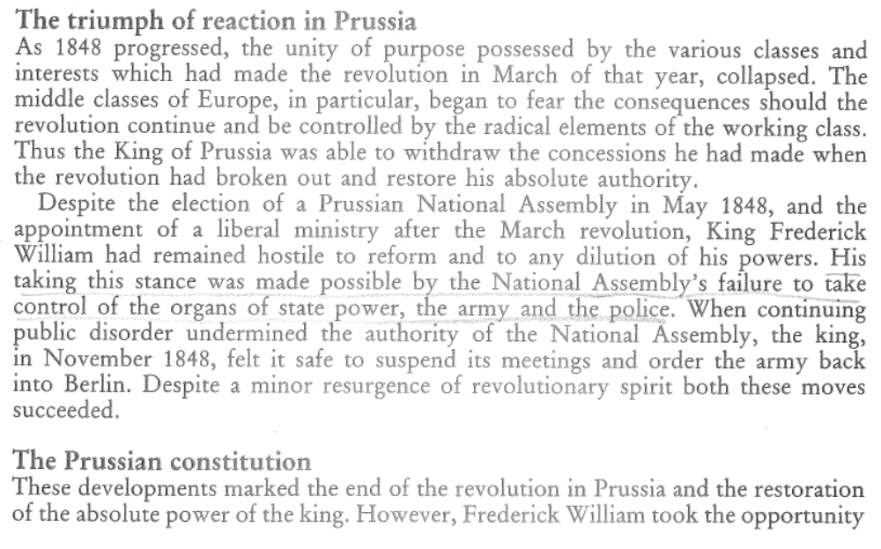
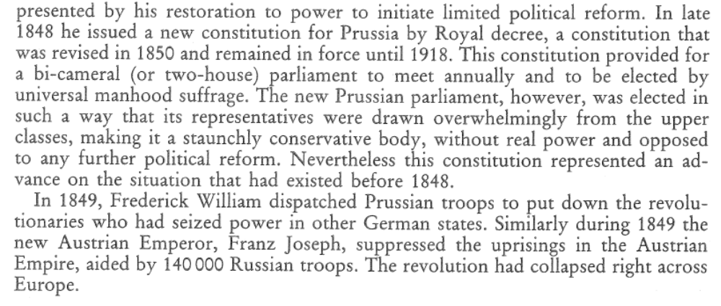
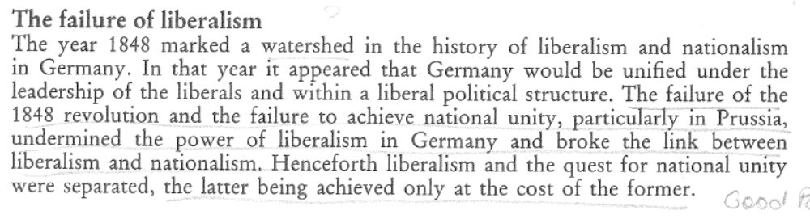

Questions
- List the states whose representatives attended the Congress of Vienna in 1815.
- Who was Prince Metternich and to which state did he belong?
- What were the two objectives of the Congress of Vienna
- List the basic freedoms which liberals were concerned to have recognised by their governments.
- What does ‘the sovereignty of the people’ mean?
- How many German states were there after the congress of Vienna?
- Which was the second ranking power among the German states?
- What was the Germanic Confederation? Which state led the Germanic Confederation?
- When and why were the Carlsbad decrees drawn up? What did the Carlsbad decrees do?
- What was the most significant economic development in the German states after 1815?
- Why was the establishment of the Zollverein in 1834 important to the political unification of the German States?
- What was the popular revolution that swept through Europe?
- Explain the role of the Frankfurt Parliament?
- How did Frederick William IV upset the plans of the Frankfurt Parliament and what were the consequences of this?
- Why did the middle classes of Europe become fearful of revolution through 1848?
- Why did the constitution of 1850 not result in political change in Prussia?
- How did the failure of the revolution of 1848 affect the influence of liberalism in Germany?

